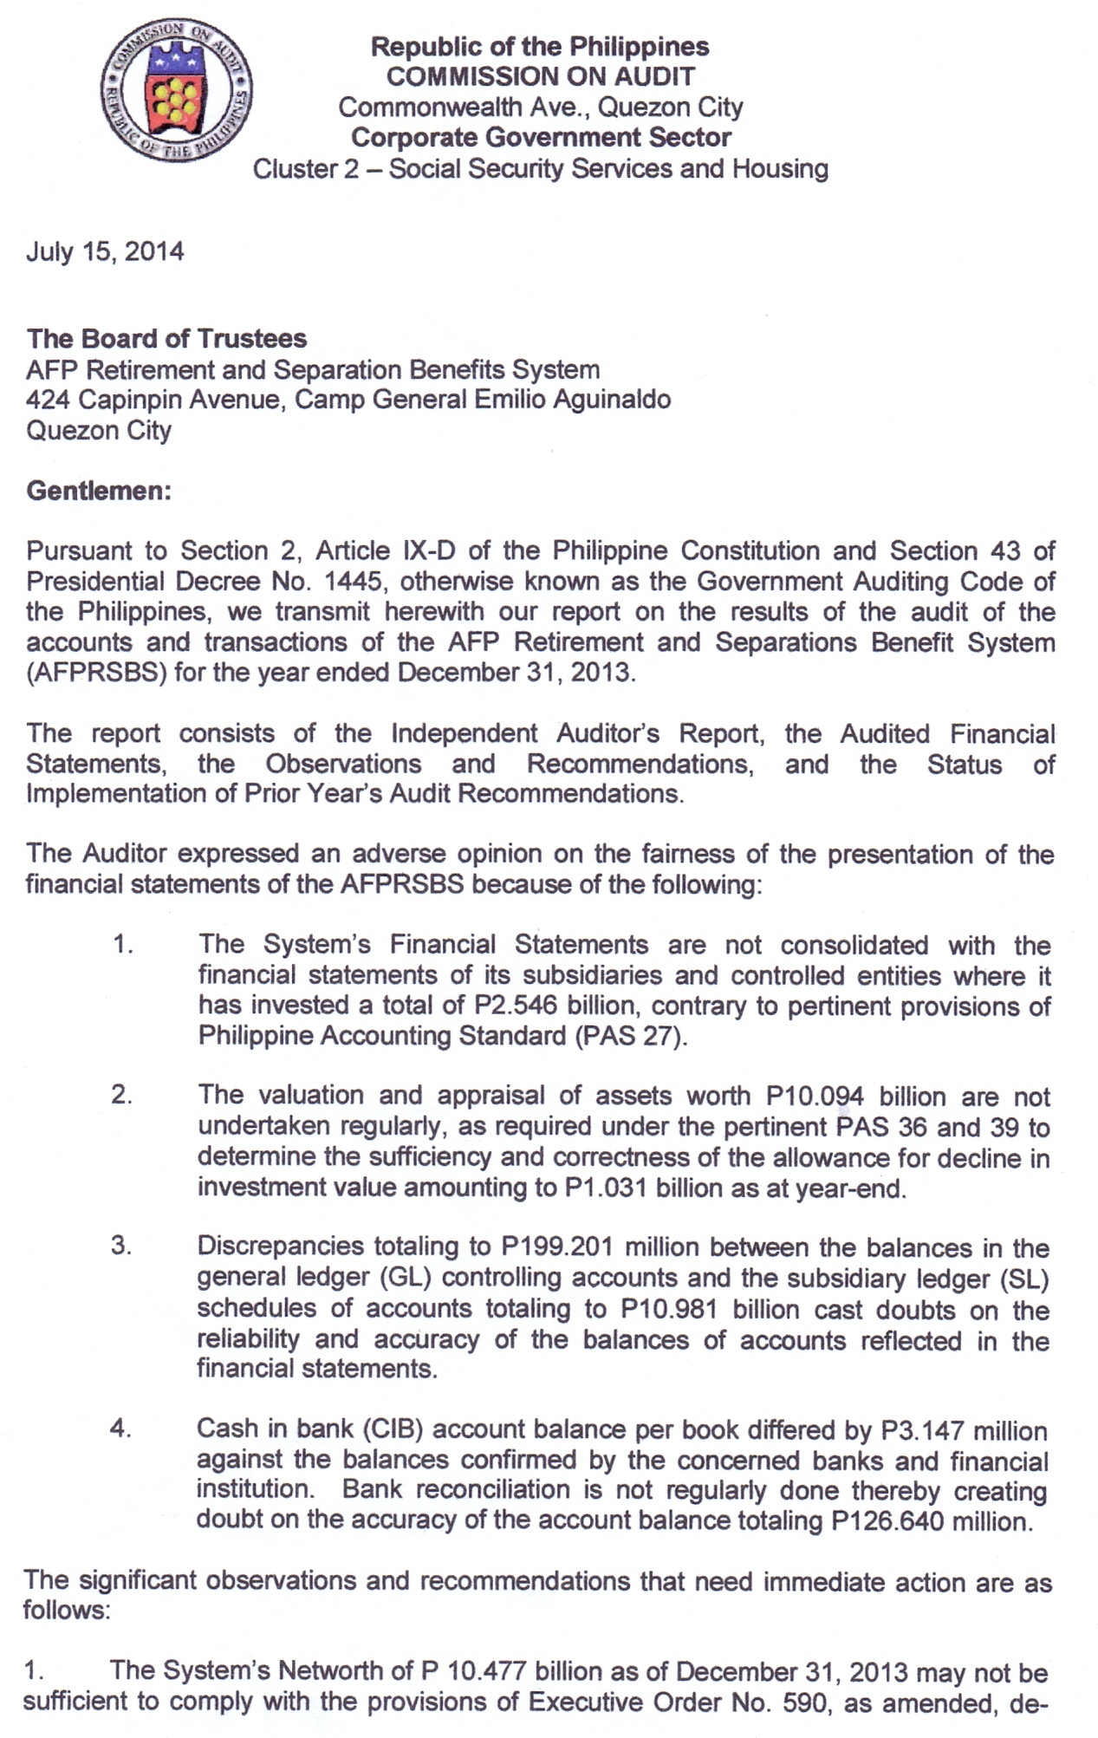

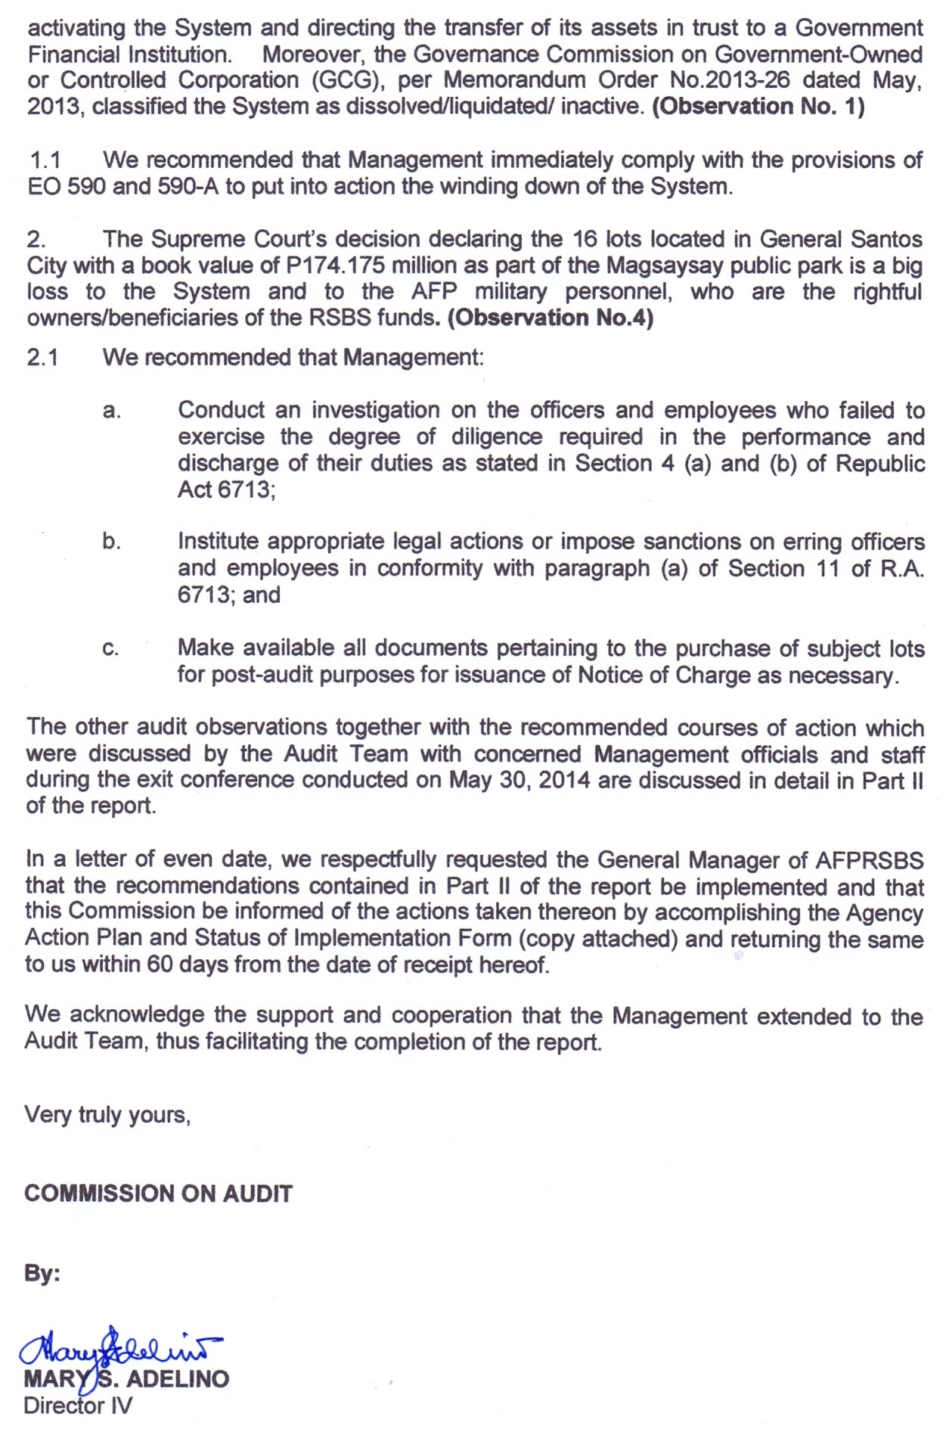

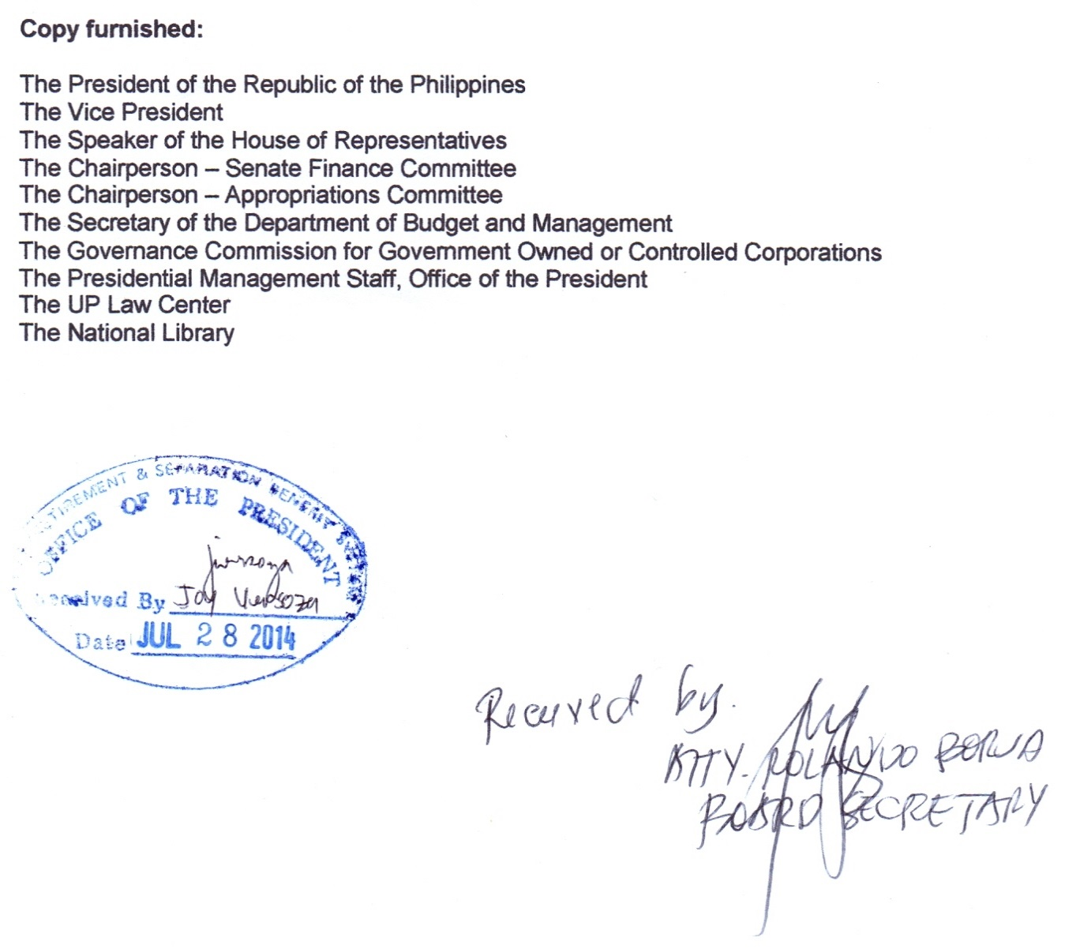

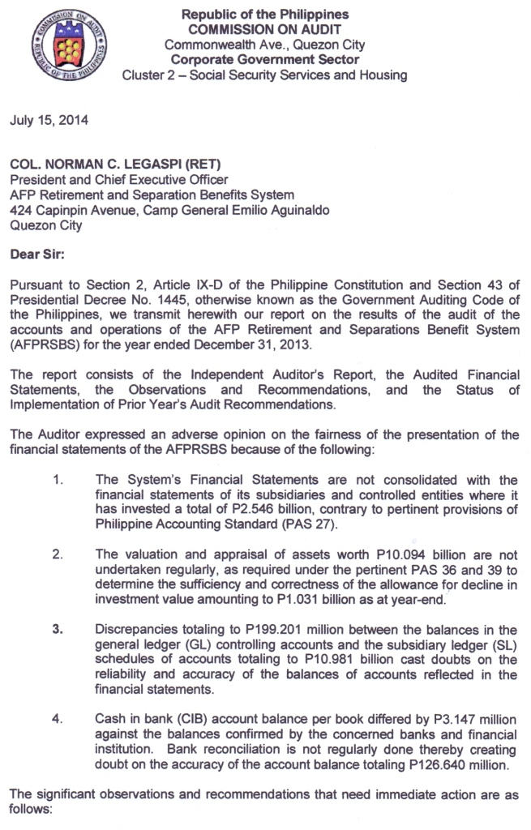

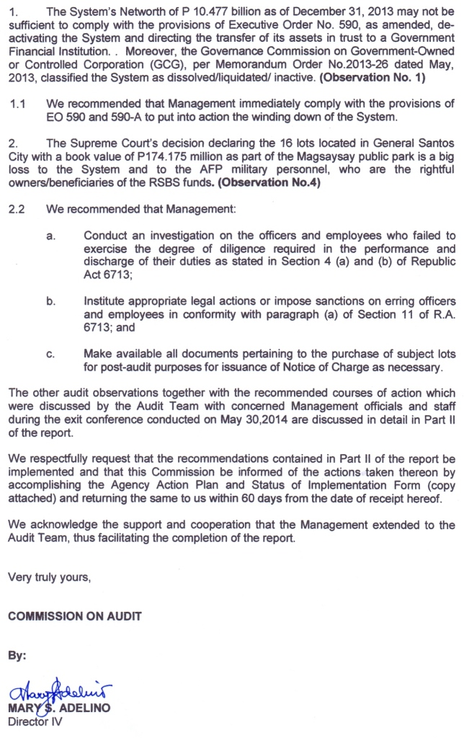

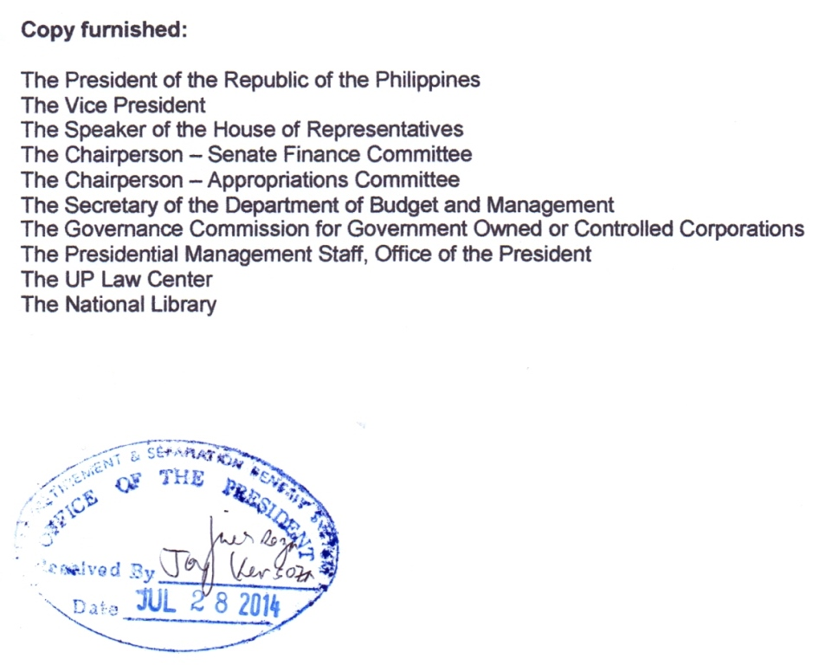

Annex A

AFP – RETIREMENT AND SEPARATION BENEFITS SYSTEM
424 Capinpin Avenue, Camp General Emilio Aguinaldo, Quezon City, Metro Manila

AGENCY ACTION PLAN and STATUS OF IMPLEMENTATION
Audit Observations and Recommendations
For the Calendar Year 2013
As of _______________________

Ref. | Audit  Observations | Audit  Recommendations | Agency Action Plan |  |  |  | Status  of  Implementation | Reason for Partial/Delay/Non-  Implementation,  if applicable | Action Taken/  Action to be Taken
 |  |  | Action Plan | Person/Dept.  Responsible | Target Implementation  Date
 |  |  |  |  | From | To

Agency sign-off:

_________________________________ ____________________
Name and Position of Agency Officer Date

Note: Status of Implementation may either be (a) Fully Implemented (FI, (b) Ongoing (O), (c) Not Implemented (NI), (d) Partially Implemented (PI), or (e) Delayed (D)

