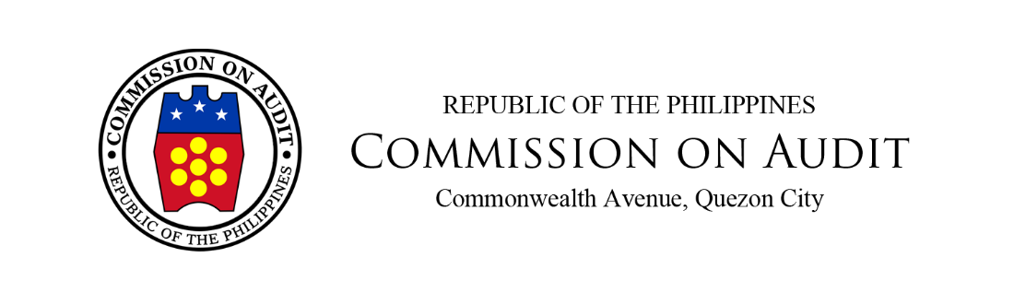

INDEPENDENT AUDITOR’S REPORT

The Board of Liquidators
AFP Retirement and Separation Benefits System
424 Capinpin Avenue, Camp General Emilio Aguinaldo
Quezon City, Metro Manila

Report on the Audit of the Consolidated Financial Statements

Adverse Opinion

We have audited the consolidated financial statements of AFP Retirement and Separation Benefits System (AFPRSBS) and its subsidiary (collectively referred as the Group), which comprise the consolidated statements of financial position as at December 31, 2022 and 2021, and the consolidated statements of comprehensive income, consolidated statements of changes in equity and consolidated statements of cash flows for the years then ended, and notes to the consolidated financial statements, including a summary of significant accounting policies.

In our opinion, because of the significance of the matters discussed in the Bases for Adverse Opinion section of our report, the accompanying consolidated financial statements do not present fairly, the consolidated financial position of the Group as at December 31, 2022 and 2021, and its consolidated financial performance and its consolidated cash flows for the years then ended in accordance with the Philippine Financial Reporting Standards (PFRSs).

Bases for Adverse Opinion

The account balances in the financial statements as at and for the years ended
December 31, 2022 and 2021 are misstated.

- The continued presentation and measurement of the assets, liabilities, equity and income and expenses accounts on a going concern assumption despite the imminent liquidation of the AFPRSBS is not in accordance with the Philippine Accounting Standard (PAS) 1 – Presentation of Financial Statements and the Conceptual Framework for Financial Reporting (CFFR). Memorandum Order (MO) No. 90, series of 2016, directs the abolition of AFPRSBS and privatization of its subsidiaries.

- The non-consolidation in the financial statements of AFPRSBS of its other subsidiaries where it has investments totaling P1.116 billion resulted in the non-elimination of all the parent and subsidiary reciprocal account balances which is not in accordance with PFRS 10-Consolidated Financial Statements. Only the financial statements of Monterrosa Development Corporation were consolidated with the financial statements of AFPRSBS.

- The Allowance for Impairment computed using a method other than that provided under PFRS 9 – Financial Instruments resulted in the overstatement by undetermined amounts of the Receivables stated at P859.370 million in CY 2022 and P826.448 million in CY 2021; Loans Receivable stated at P1.091 billion in CY 2022 and P1.046 billion in CY 2021; Installment Contract Receivable stated at P325.778 million in CY 2022 and P273.571 million in CY 2021; and Investment in Bonds stated at P2.349 billion in CY 2022 and P2.375 billion in CY 2021.

There were noted variances in some accounts which remain unreconciled. There is a variance of P116.560 million and P596.622 million as at December 31, 2022 and 2021, respectively, between the general ledger and Integrated Financial Management System subsidiary ledger balances of the Members’ Contributions (MC) Payable and Estimated Liability on MC Earnings accounts. Also, there is a variance of 146,010 square meters of raw lands with equivalent cost of P84.442 million as at December 31, 2022 and 2,448,871 square meters with equivalent cost of P768.743 million as at December 31, 2021 between the total land area per Transfer Certificates of Title and those recorded in the Real Estate Inventories and Landbanking Assets accounts. The status of records of the Group did not permit us to apply alternative audit procedures. Consequently, we were unable to determine whether any adjustments on the balances of the above-mentioned accounts, as presented in the consolidated financial statements, were necessary.

We conducted our audits in accordance with International Standards of Supreme Audit Institutions (ISSAIs). Our responsibilities under those standards are further described in the Auditor’s Responsibilities for the Audit of the Consolidated Financial Statements section of our report. We are independent of the Group in accordance with the Code of Conduct and Ethical Standards for Commission on Audit Officials and Employees (Code of Ethics) together with the ethical requirements that are relevant to our audit of the consolidated financial statements in the Philippines, and we have fulfilled our other ethical responsibilities in accordance with these requirements and the Code of Ethics. We believe that the audit evidence we have obtained is sufficient and appropriate to provide a basis for our adverse opinion.

Emphasis of Matter

We draw attention to Note 2 to the consolidated financial statements in relation to Note 13.1. On April 19, 2016, the Board of Liquidators (BOL) approved the stoppage of the collection of five per cent members’ contributions (MCs) and the accrual of interests thereon effective March 31, 2016, as per Board Resolution (BR) No. SPL-01-2016. The implementation of Accelerated Refund of MCs was approved by the BOL on June 13, 2018. Consequently, it was approved by the GCG En Banc, subject to several conditions, per letter from GCG dated September 7, 2018. Policies and procedures for the implementation of the Accelerated Refund Program were established in coordination with AFP Units. This covers the refund of contribution to an estimated 105,200 members for a period of three (3) years. The AFPRSBS commenced the pay-out of Accelerated Refund in January 2019, thus, effectively stopping the granting of Advance Refund Loans. As at December 31, 2022, a total of P12.395 billion in principal and interests was refunded to 114,000 members/claimants.

We further draw attention to Note 2 to the consolidated financial statements which describes that pursuant to MO No. 90, AFPRSBS continuously engages itself in various business operations necessary to wind down its operations. These include the management of funds and investments in real estate projects and foreclosed assets. In late 2016, AFPRSBS submitted its Winding Down Plan to the Governance Commission for GOCCs (GCG) which states that the primary objective of the same is to raise P16 billion to refund all the MCs within three years or by December 31, 2019. However, the GCG clarified in its letter dated March 29, 2019, that the three-year period to liquidate a dissolved corporation can be extended until the liquidation is fully completed.

We likewise draw attention to Note 29 to the consolidated financial statements which describe the uncertainties related to pending cases in several courts involving various claims against the Group.

Our opinion is not modified concerning the matters discussed in the preceding paragraphs.

Responsibilities of Management and Those Charged with Governance for the Consolidated Financial Statements

Management is responsible for the preparation and fair presentation of the consolidated financial statements in accordance with PFRSs, and for such internal control as management determines is necessary to enable the preparation of consolidated financial statements that are free from material misstatement, whether due to fraud or error.

In preparing the consolidated financial statements, management is responsible for assessing the Group’s ability to continue as a going concern, disclosing, as applicable, matters related to going concern and using the going concern basis of accounting unless management either intends to liquidate the Group or to cease operations, or has no realistic alternative but to do so.

Those charged with governance are responsible for overseeing the Group’s financial reporting process.

Auditors’ Responsibilities for the Audit of the Consolidated Financial Statements

Our objectives are to obtain reasonable assurance about whether the consolidated financial statements as a whole are free from material misstatement, whether due to fraud or error, and to issue an auditor’s report that includes our opinion. Reasonable assurance is a high level of assurance, but is not a guarantee that an audit conducted in accordance with ISSAIs will always detect a material misstatement when it exists. Misstatements can arise from fraud or error and are considered material if, individually or in the aggregate, they could reasonably be expected to influence the economic decisions of users taken on the basis of these consolidated financial statements.

As part of an audit in accordance with ISSAIs, we exercise professional judgment and maintain professional skepticism throughout the audit. We also:

- Identify and assess the risks of material misstatement of the consolidated financial statements, whether due to fraud or error, design and perform audit procedures responsive to those risks, and obtain audit evidence that is sufficient and appropriate to provide a basis for our opinion. The risk of not detecting a material misstatement resulting from fraud is higher than for one resulting from error, as fraud may involve collusion, forgery, intentional omissions, misrepresentations, or the override of internal control;

